**INSPIRATIONBASE**

*A collection of ethical leadership speeches*

Alexandria Ocasio-Cortez

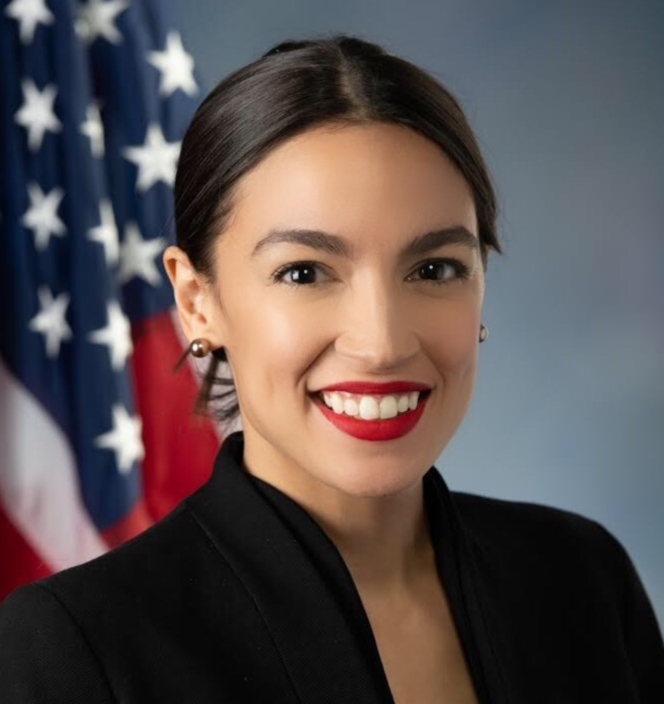

Alexandria Ocasio-Cortez became a US congresswoman in January 2019 and “has remained committed to serving working-class people over corporate interests and advocating for social, racial, economic, and environmental justice”. She “is a third-generation Bronxite, educator, and organizer serving the 14th district of New York in the Bronx and Queens. Ocasio-Cortez grew up experiencing the reality of New York’s rising income inequality, inspiring her to organize her community and run for office on a progressive platform”. Source: official biography ([link](https://ocasio-cortez.house.gov/about/biography))

|  |  |  |  |  |
| --- | --- | --- | --- | --- |
| **AOC 1*. MSNBC Town Hall meeting interview (extracts)*** | | | |  |
| Well, so in the fall of 2008, as we all know the markets crashed and my father also passed away from lung cancer. And all of a sudden overnight, I was the daughter of a single mom with a younger brother and we had to work our way through that situation. We`re on the brink of foreclosure. Our home was about to be taken away. I started working in restaurants. And so for me as an economics graduate in the wake of the recession, I started -- I decided that I needed to go back home to the Bronx and that I needed a work in education advocacy and organizing, but just economically speaking that wasn`t enough. So I also worked in restaurants and it wasn`t that experienced being shoulder to shoulder with undocumented busboys and chefs with children, people at my age that were basically in the same exact situation. So many of the people that I worked with were college graduates who had a parent pass away or someone in their family struck with an enormous medical issue and it really became clear from that experience that our issues and our economic issues are systemic and they`re not an accident. They are a result of an economic system that enriches the few in enormous amount at the cost of the working class and middle class…  So this issue is not just about our climate. First and foremost, we need to save ourselves, period. There will be no future for the Bronx, there will be no livable future for generations coming for any part of this country in a way that is better than the lot that we have today if we don`t address this issue urgently and on the scale of the problem. But how I access this issue is that I started looking at all of our problems. We have runaway income inequality. We are at one of our most inequal points economically speaking in American history. We are dealing with the crisis of how our economy is even made up. Our economy is increasingly financialized which means we are making profits off of interest, off of leasing your phone, off of doing all of these things, but we aren`t producing and we are an innovating in the way that we need to as an economy. And I also is looking at our issues of social justice, social and racial justice of which we are -- which we have a nexus here in the Bronx. And what I started thinking about to myself was listen, we`re looking at all of these issues, Medicare for all, a living wage, tuition free public colleges and universities, and there`s this false idea that we need to put them all in a line and say do this or do that. Do you care about health care or do you care about the economy or jobs. And then I started to realize that these are not different problems. These are all part of the same problem. And this is -- in the past when we`ve confronted this type of stagnation and this type of systemic threat as a country -- first of all we`ve been here before. We`ve been here before with the Great Depression. We`ve been here before with World War Two even the Cold War. And the answer has been an ambitious and directed mobilization of the American economy to direct and solve our problem, our biggest problem. And historically speaking, we have mobilized our entire economy around war. But I thought to myself it doesn`t have to be that way especially when our greatest existential threat is climate change. And so to get us out of this situation, to revamp our economy to create dignified jobs for working Americans, to guarantee health care and elevate our educational opportunities and attainment, we will have to mobilize our entire economy around saving ourselves and taking care of this planet…And I think it`s important to note that this is here. This is not something that`s coming. We have -- you know, on the events of September 11, 2001, thousands of Americans died in one of the -- in the largest terrorist attack on U.S. soil. And our National Response whether we agree with it or not, our national response was to go to war in one then eventually two countries. 3,000 Americans in Puerto Rico in the aftermath of Hurricane Maria, where is our response? | | | | |
| **Date** | 29/03/19 | **Source** | MSBNC ([link](https://www.msnbc.com/transcripts/all-in/2019-03-29-msna1214456)) | |

|  |  |  |  |  |
| --- | --- | --- | --- | --- |
| **AOC 2*. MLK NOW event interview*** | | | |  |
| Interviewer: I'm Joe Billionaire. I made widgets. I sold those widgets. I made billions of dollars, you know, selling those widgets, making those widgets. Therefore, those billions of dollars are mine. Why am I the enemy of healthcare?  AOC: Well, you didn't make those widgets, did you? Because you employed thousands of people and paid them less than a living wage to make those widgets for you. You didn't make those widgets. You sat on a couch while thousands of people were paid modern-day slave wages. You made that money off the backs of undocumented people. You made that money off of the backs of black and brown people being paid under a living wage. You made that money off of the backs of single mothers. And all of these people who are literally dying because they can’t afford to live. **And so no one ever makes a billion dollars. You take a billion dollars.** | | | | |
| **Date** | 20/01/2020 | **Source** | Blackout for Human Rights MLK NOW 2020 ([link](https://www.youtube.com/watch?v=q3-QvoIfpxc)) | |

|  |  |  |  |  |
| --- | --- | --- | --- | --- |
| **AOC 3. *Response to verbal abuse from Representative Yoho*** | | | |  |
| I walked back out and there were reporters in the front of the Capitol and in front of reporters Representative Yoho called me, and I quote, “fucking bitch”.. I will not stay up late at night waiting for an apology from a man who has no remorse over calling women and using abusive language towards women, but what I do have issue with is using women, our wives and daughters, as shields and excuses for poor behavior. Mr. Yoho mentioned that he has a wife and two daughters. I am two years younger than Mr. Yoho’s youngest daughter. I am someone’s daughter too. My father, thankfully, is not alive to see how Mr. Yoho treated his daughter. My mother got to see Mr. Yoho’s disrespect on the floor of this House towards me on television and I am here because I have to show my parents that I am their daughter and that they did not raise me to accept abuse from men…was not just an incident directed at me, but when you do that to any woman, what Mr. Yoho did was give permission to other men to do that to his daughters. In using that language in front of the press, he gave permission to use that language against his wife, his daughters, women in his community, and I am here to stand up to say that is not acceptable. | | | | |
| **Date** | 27/07/2020 | **Source** | NBC news ([video](https://www.youtube.com/watch?v=tSZcdMCHn2o) [transcript](https://www.rev.com/blog/transcripts/rep-alexandria-ocasio-cortez-floor-speech-about-yoho-remarks-july-23)) | |
| **AOC 4. *Nomination of Bernie Saunders for President*** | | | |  |
| Good evening, bienvenidos, and thank you to everyone here today endeavoring towards a better, more just future for our country and our world, in fidelity and gratitude to a mass people's movement working to establish 21st century social, economic and human rights, including guaranteed healthcare, higher education, living wages and labour rights for all people in the United States; a movement striving to recognize and repair the wounds of racial injustice, colonization, misogyny and homophobia, and to propose and build reimagined systems of immigration and foreign policy that turn away from the violence and xenophobia of our past; a movement that realizes the unsustainable brutality of an economy that rewards explosive inequalities of wealth for the few at the expense of long-term stability for the many and who organized a historic grassroots campaign to reclaim our democracy; in a time when millions of people in the United States are looking deep systemic solutions to our crises of mass evictions, unemployment and lack of health care, in espirito del pueblo and out of a love for all people, I hereby second the nomination of Senator Bernard Sanders for president of the United States of America. | | | | |
| **Date** | 18/08/20 | **Source** | Newsweek ([link](https://www.newsweek.com/full-transcript-alexandria-ocasio-cortezs-60-second-speech-dnc-1526025)) | |